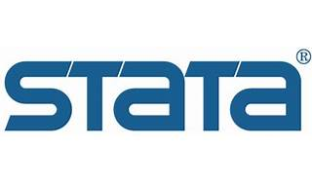

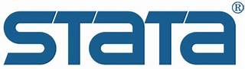

Explore

[Certainly**Stata** is a comprehensive, integrated software package used for **data manipulation, visualization, statistics, and automated reporting**1](https://www.stata.com/products/overview.html). Here are five free reference links where you can learn more about Stata:

1. [**Stata Overview**](https://www.stata.com/products/overview.html): Explore the features and capabilities of Stata.
2. [**Stata Documentation**](https://www.stata.com/features/documentation/): Access over 18,000 pages of detailed documentation, including methods, formulas, and examples.
3. [**Stata Video Tutorials**](https://www.stata.com/links/video-tutorials/): Watch short video tutorials covering various topics, from simple linear regression to advanced statistical techniques.
4. [**Stata Learn**](https://www.stata.com/learn/): Participate in in-depth training courses taught by StataCorp experts virtually or in your facility.
5. [**Stata Wikipedia**](https://en.wikipedia.org/wiki/Stata): Get an overview of Stata’s features and applications.

Feel free to explore these resources to enhance your understanding of Stata! 📊🔍📚